Lab practice test 2 - Jyou338, 6341092

1. and 2.

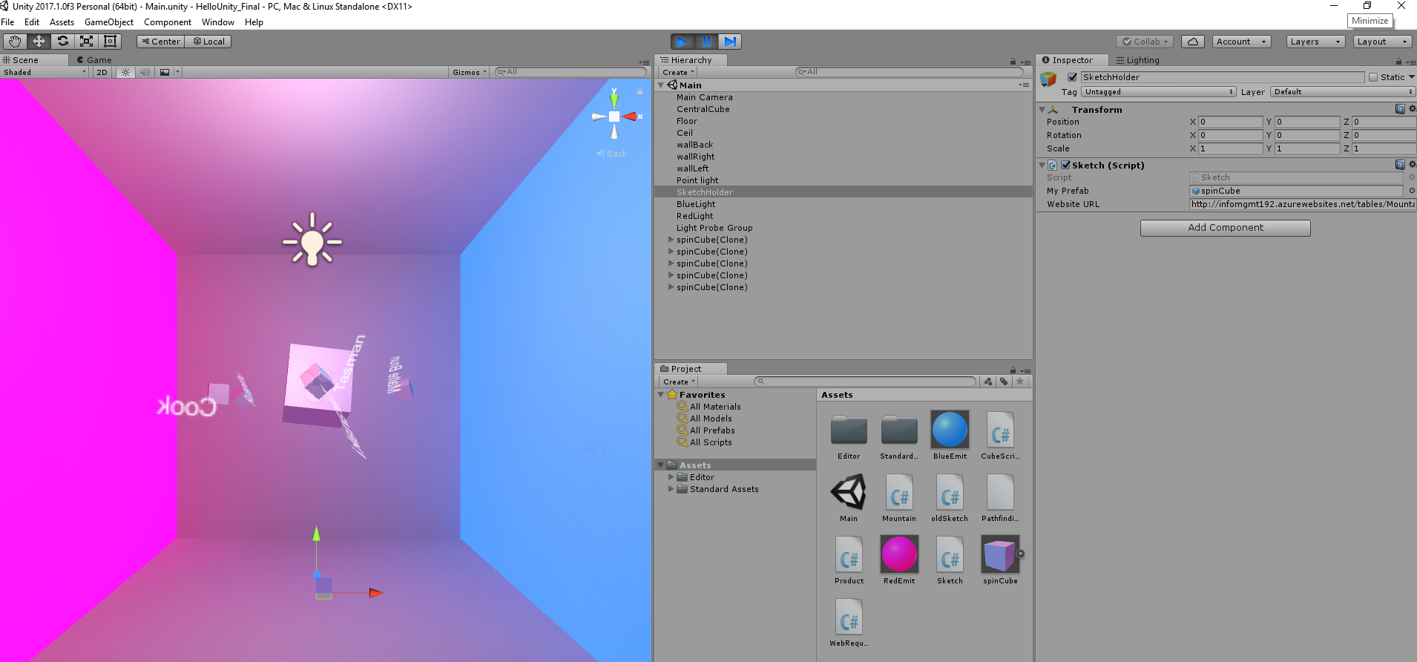Created new mountain class to deserialize the GET request into mountain objects.

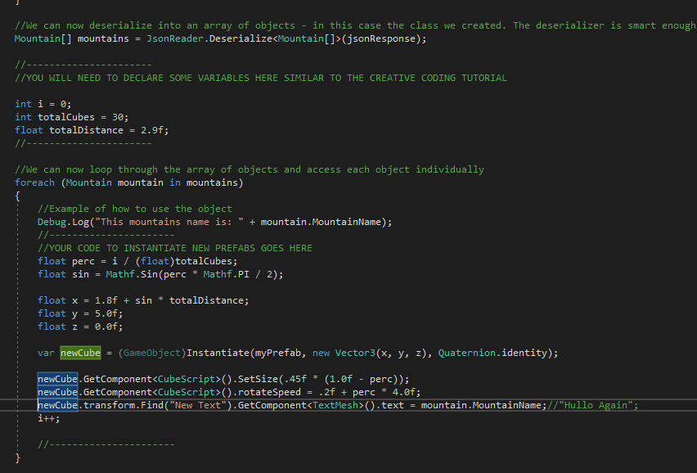

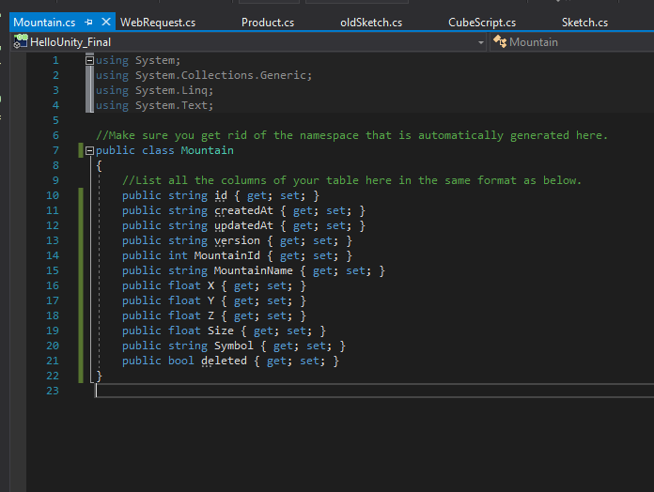

3.

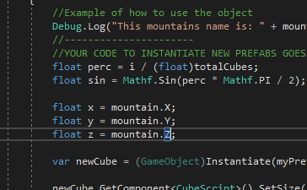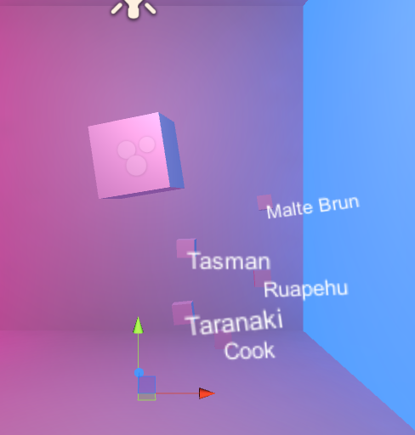Set the instantiated x, y, and z values to the mountain object x, y, and z values.

4.

Made them stop spinning around the central cube but setting rotateSpeed to 0.

Set the size using mountain size \* 0.2f.

Created new spinSphere prefab and set it as a variable in the Sketch script. Depending on the symbol property, I create a cube or sphere prefab.

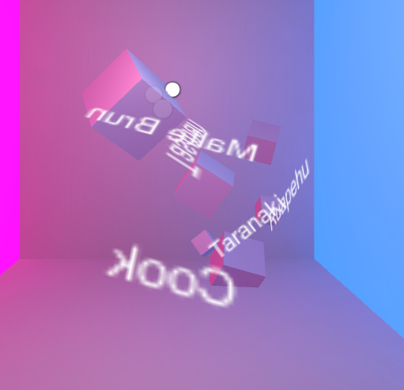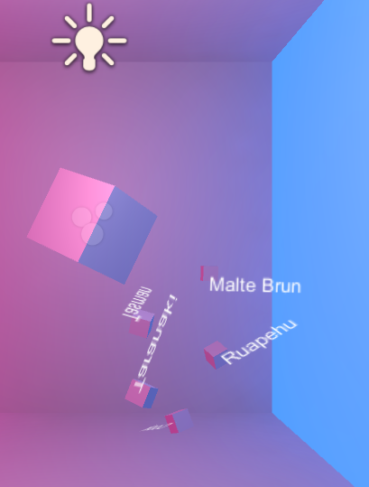

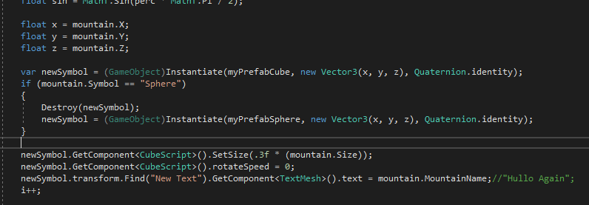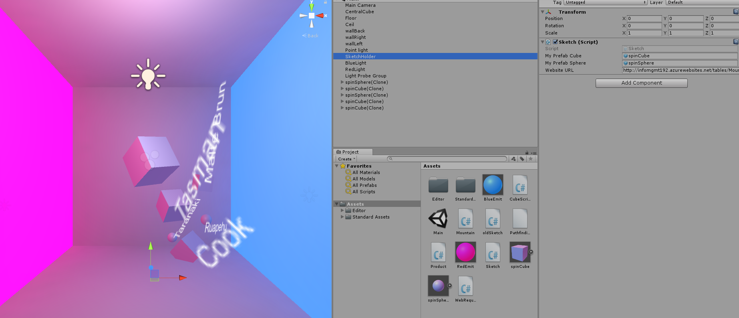

5.

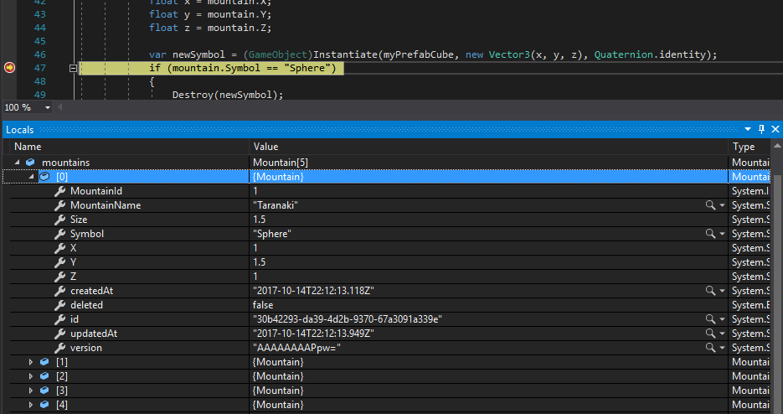

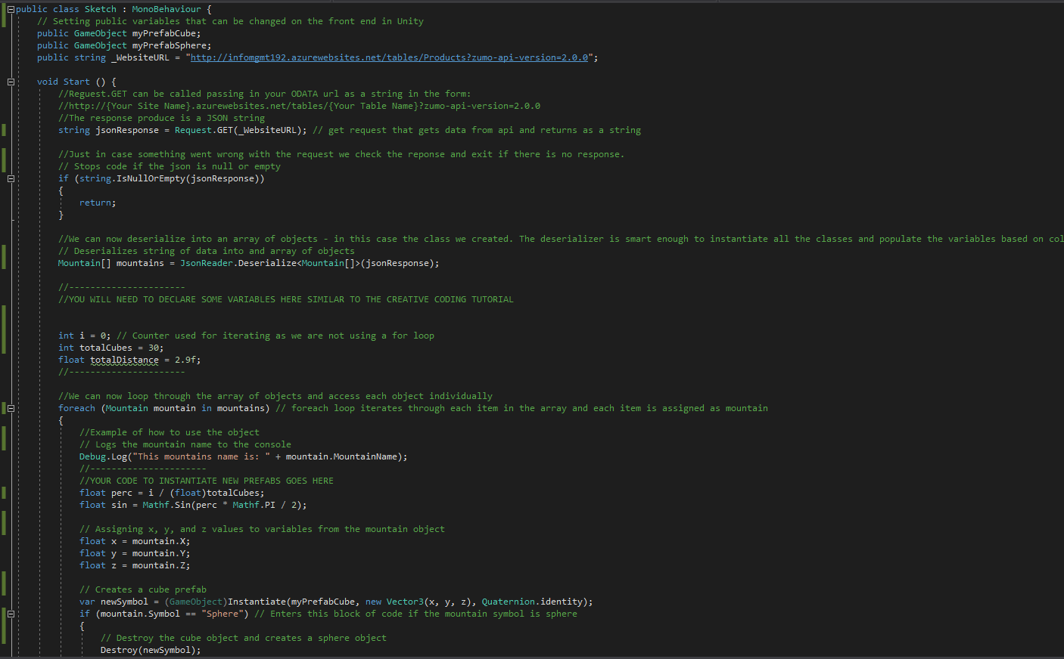6.

